WEBSITE CHANGES
1. https://himanshumehta.com/books
Please remove the Flipkart option and change the picture to the below attached image
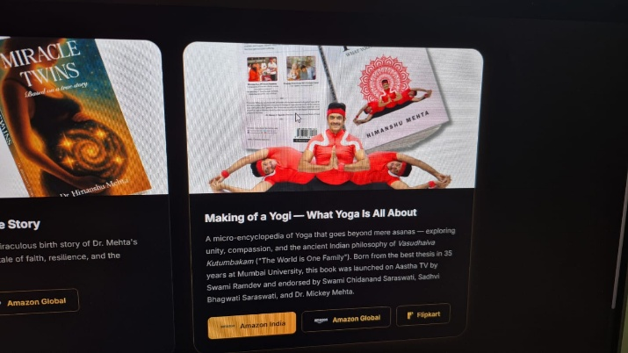
2. https://himanshumehta.com/yoga-training
https://youtu.be/16JzJjnRzYc?si=3XSzbyRAgqiGHPBy
https://youtu.be/FwWvZJoZUM0?si=XcvgetJAELBYhdhC
Add these to the yoga training section
3. https://himanshumehta.com/qr-connect
Mobile number for doctors to send review videos on WhatsApp +91 9152650234

